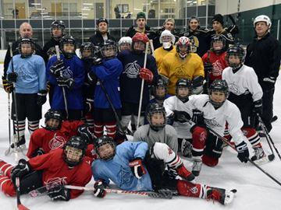
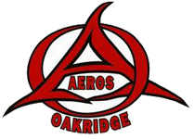

On November 29th, 2014, the Oakridge Aeros Minor Hockey Association and The London Knights (OHL), in collaboration with Professional Goalie Coach David Rook, we will be collecting non-perishable items for the London Food Bank!
DROP OFF DAY is November 29th 9am-5pm at Oakridge Arena
For more information contact your coach or
Mark or Kirsten Berry
Oakridge Aeros Hockey
5196700747
Coach4food@bell.net
Here are some ideas:
Canned fruit
Canned vegetables
Canned meats
Brown beans
Baby food
Pasta and rice

Last years Coach for food winning team
David Rook is a professional goalie coach. He is a London resident and he is currently the Goalie Development Coach for the Nashville Predators. David coached with the Memorial Cup winning London Knights, the Columbus Blue Jackets as well as professional teams in the European leagues.
Each Oakridge Team is encouraged to participate by donating non-perishable food items or by making a cash donation.
($1 cash donation is equal to 1.5lbs of food!)The team that brings in the most food wins a professionally coached practice with David Rook and the London Knights!!

